**Production Costing - Manufacturing Sector**

GOKULNATH K & E24755

**Overview**

Production costing in the manufacturing sector involves analyzing direct and indirect costs, such as raw materials, labor, and overhead, to determine the total cost of production. A data analyst helps track and optimize these costs using data-driven insights, improving cost-efficiency and profitability. By identifying cost trends, inefficiencies, and potential savings, they enable better decision-making in resource allocation and pricing strategies. Accurate production costing is essential for maintaining competitive pricing and maximizing margins in manufacturing.

**Objective**

1. **Optimize Cost Allocation:** Analyze and allocate production costs to identify cost-saving opportunities.
2. **Monitor Cost Trends:** Track cost fluctuations over time to understand patterns and address inefficiencies.
3. **Improve Resource Utilization:** Use data to optimize the use of raw materials, labor, and equipment.
4. **Enhance Profitability:** Provide insights on reducing production costs to maximize profit margins.
5. **Support Pricing Strategies:** Analyze production costs to ensure competitive and sustainable pricing.
6. **Reduce Waste:** Identify areas of wastage and implement cost-effective production practices.
7. **Forecast Costs:** Use historical data to predict future production costs and plan budgets.

**Assigned Task(s)**

* Production Costing - Manufacturing Sector.

**Task Details**

* **Task 32 :** Production costing in the manufacturing sector involves analyzing direct and indirect expenses to determine total production costs. Data analysts use insights to optimize cost efficiency, resource use, and profitability.
* **Status:** Completed.
* **Details:**

1. Cost Calculation: Computed direct costs (raw material + labor) and indirect costs (overhead + maintenance + utilities + packaging).
2. Cost Summary: Created a summary DataFrame showing product IDs with direct, indirect, and total costs.
3. Percentage Calculation: Calculated percentages of direct and indirect costs relative to total costs.
4. Cost per Unit & Efficiency: Calculated cost per unit and an efficiency metric (units produced per total cost).
5. Bar Plot: Visualized direct vs. indirect costs using a bar plot.
6. Pie Chart: Displayed the cost breakdown of a selected product with a pie chart.
7. Line Plot: Compared direct and indirect cost percentages across products using a line plot.
8. Efficiency Identification: Identified the product with the highest efficiency.
9. Correlation Heatmap: Analyzed correlations between cost components using a heatmap.

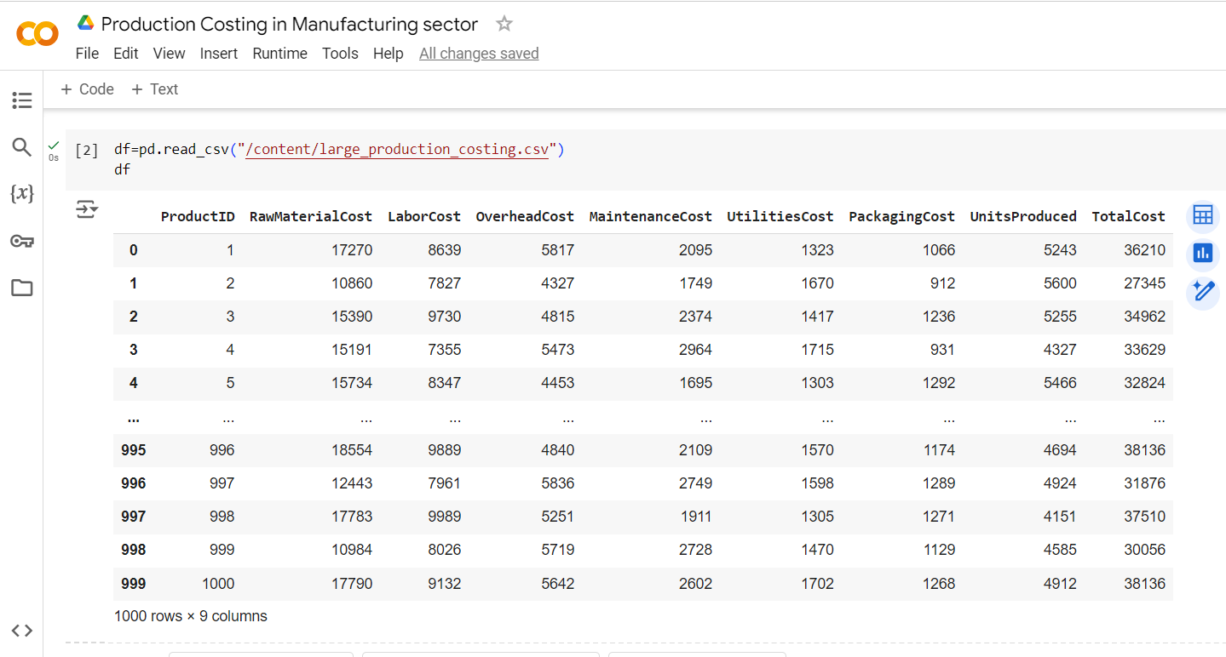

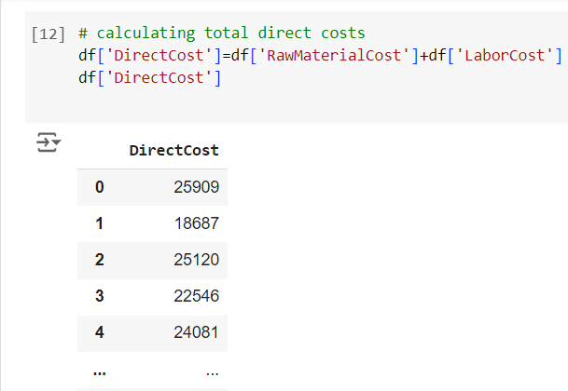

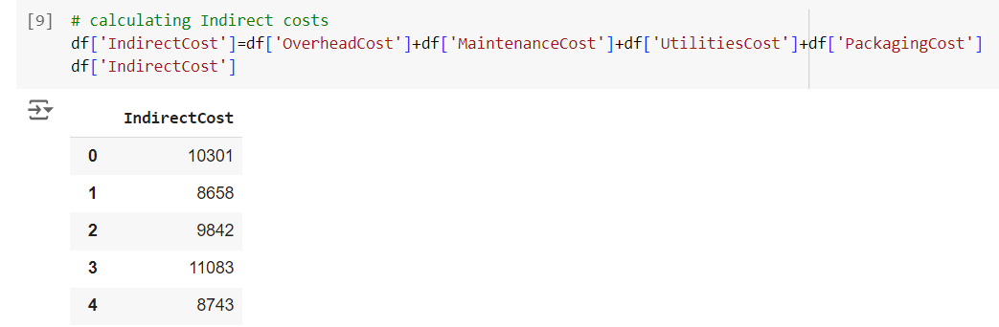

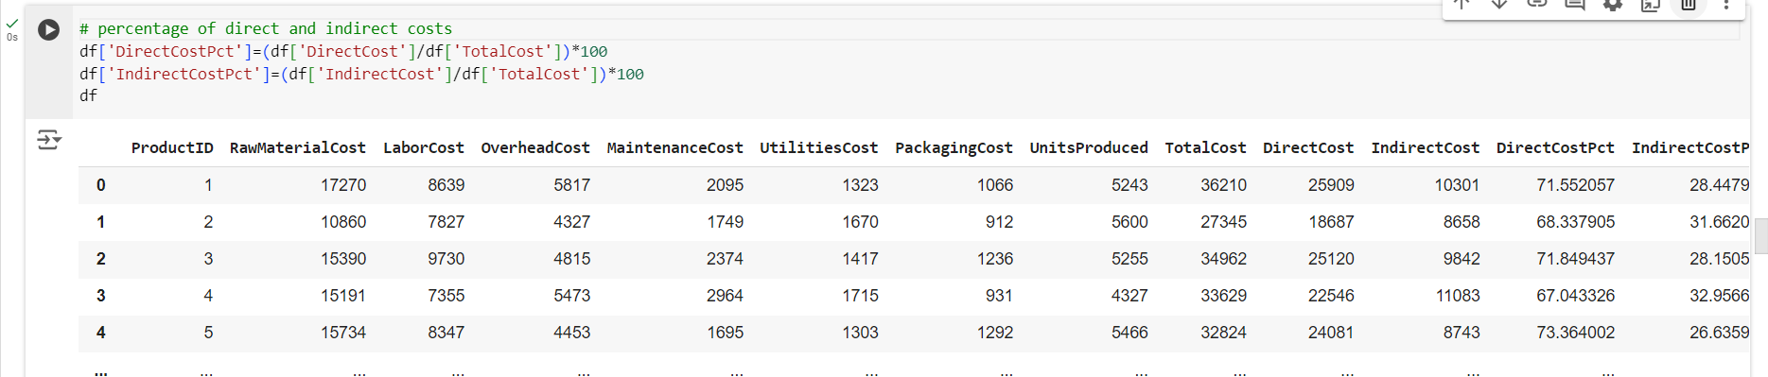

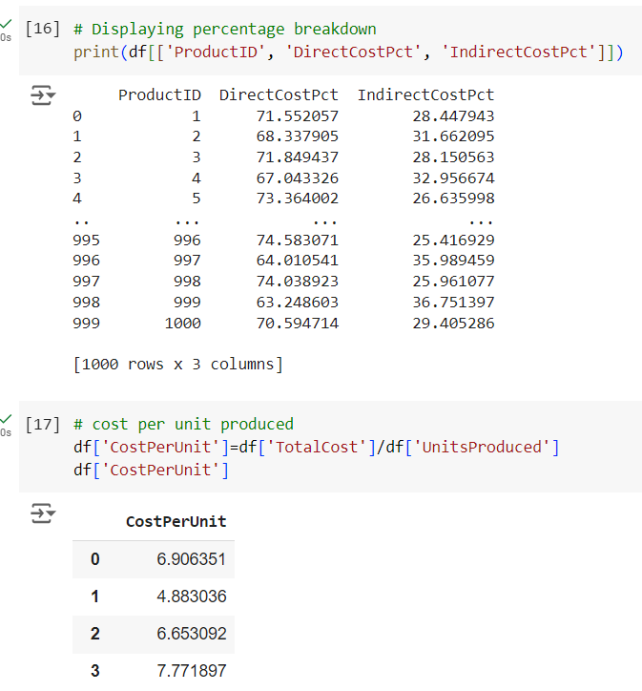

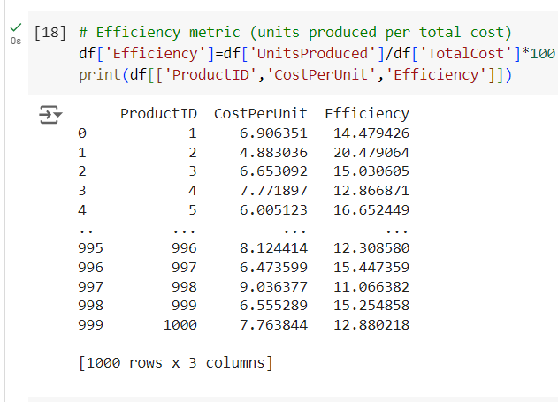

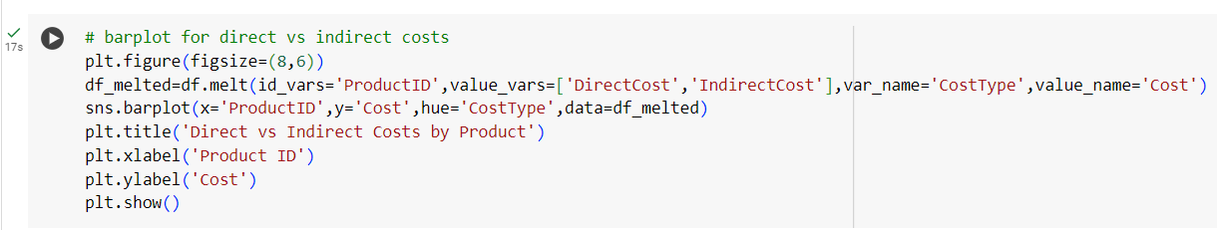

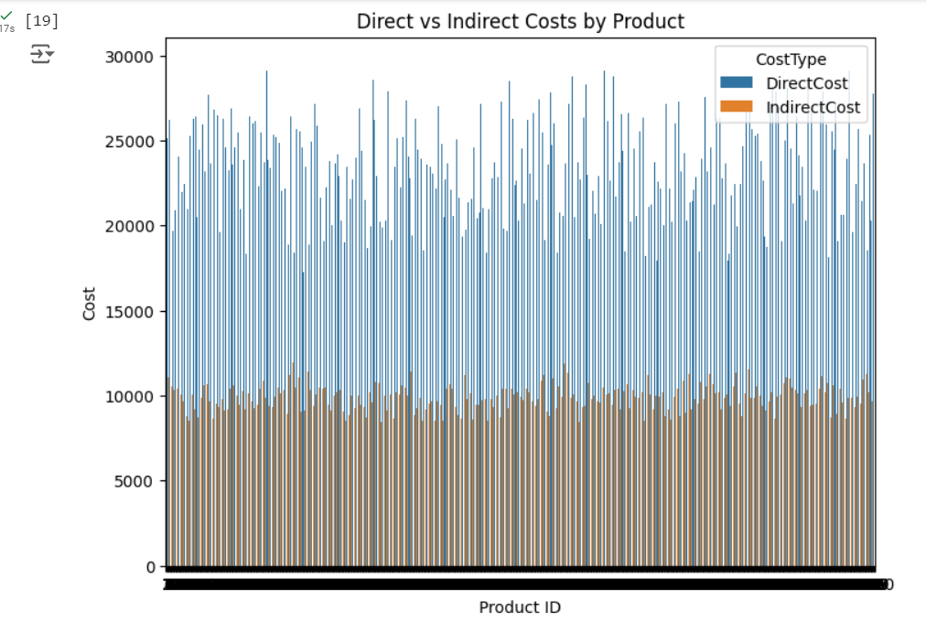

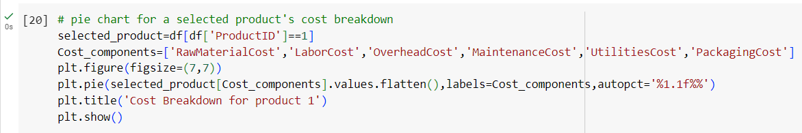

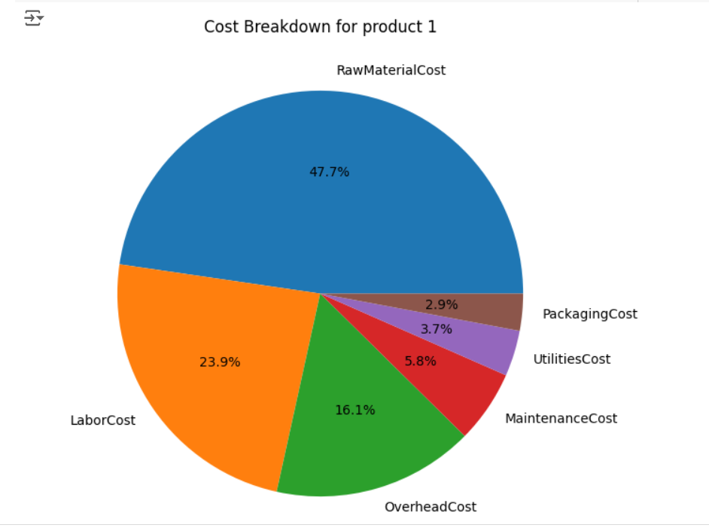

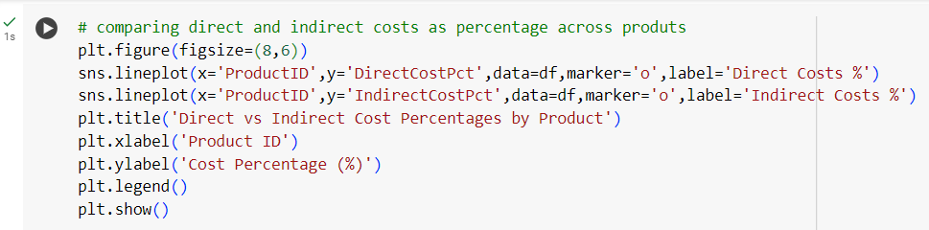

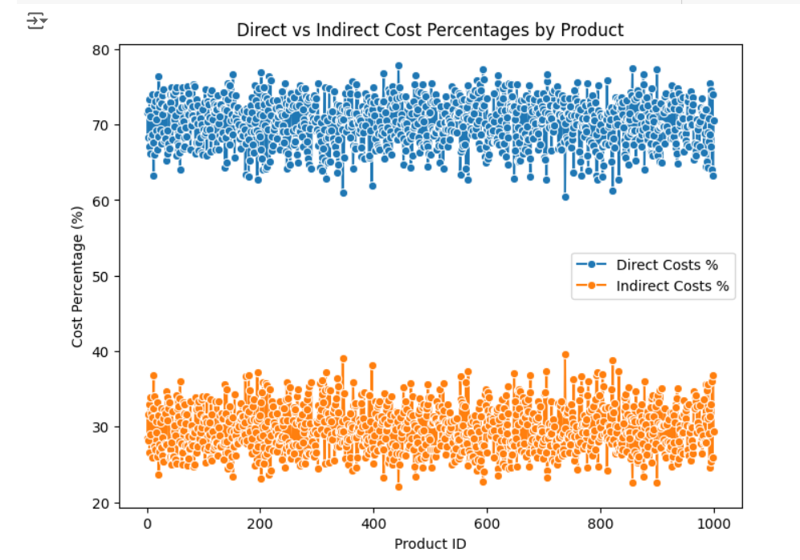

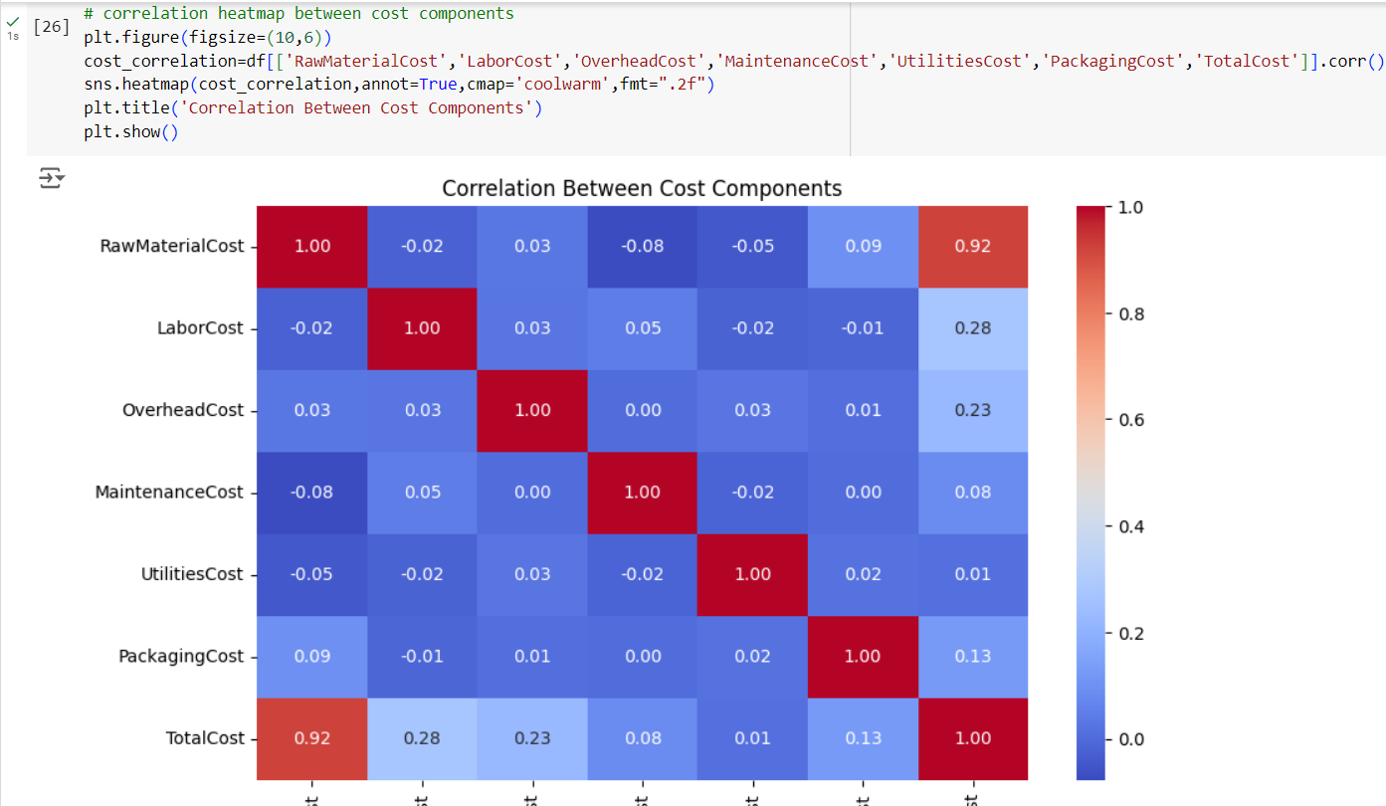

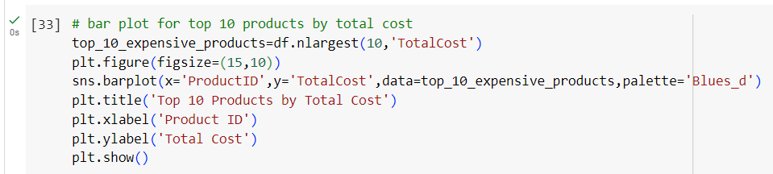

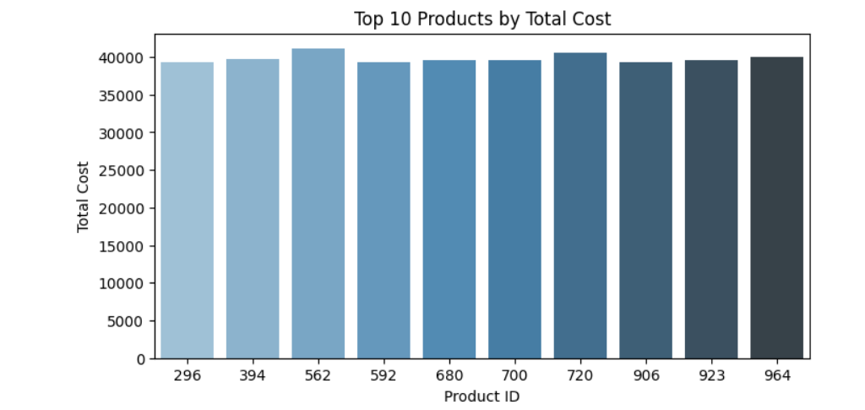

**Progress**

* **Accomplishments:**

1. Successfully computed total direct and indirect costs for each product, enhancing financial clarity.
2. Developed a summary DataFrame that organizes and presents key cost information (direct, indirect, total) for each product.
3. Established direct and indirect cost percentages, facilitating better cost management and decision-making.
4. Derived cost per unit and efficiency metrics, providing insights into production effectiveness.
5. Created a bar plot to visually compare direct vs. indirect costs across products, improving data interpretation.
6. Produced a pie chart detailing the cost breakdown for a selected product, aiding in understanding individual cost components.
7. Generated a line plot to analyze trends in cost percentages, enhancing awareness of cost structure changes.
8. Highlighted the product with the highest efficiency, showcasing potential best practices.
9. Provided a correlation heatmap that reveals relationships between cost components, supporting strategic cost analysis.

* **Metrics:**

1. Sum of raw material and labor costs for each product.
2. Sum of overhead, maintenance, utilities, and packaging costs for each product.
3. Overall cost calculated for each product, including both direct and indirect costs.
4. Percentage of total costs attributed to direct costs for each product.
5. Percentage of total costs attributed to indirect costs for each product.
6. Total cost divided by the number of units produced for each product.
7. Units produced per total cost, expressed as a percentage.
8. Proportion of each cost component (raw materials, labor, overhead, etc.) for the selected product (Product 1).
9. Correlation coefficients between different cost components, indicating their relationships.

**Challenges and Solutions**

* **Challenges Faced:**

1. Inaccurate cost data can lead to misleading conclusions and poor decision-making.
2. Difficulty in appropriately allocating indirect costs to specific products, impacting profitability analysis.
3. Fluctuating prices of raw materials and labor can complicate cost forecasting and budgeting.
4. Managing and tracking multiple cost components can be cumbersome and error-prone.
5. Employees may resist new costing methodologies or tools, hindering implementation efforts.

* **Solutions Implemented:**

1. Implement rigorous data validation techniques to ensure accuracy and reliability in cost data.
2. Use ABC(ACTIVITY BASED COSTING) methods to improve allocation of indirect costs based on actual activities driving costs.
3. Conduct frequent reviews of cost structures to adapt to market changes and refine forecasting methods.
4. Employ software solutions to automate cost tracking and reporting, reducing manual errors.
5. Develop training and communication plans to facilitate acceptance of new costing practices among employees.

**Next Steps**

* **Upcoming Tasks:** Utilize data analytics, adopt continuous improvement methodologies, embrace technology, enhance collaboration, focus on employee training, monitor KPIs, stay adaptable, and engage stakeholders to effectively tackle upcoming tasks in the manufacturing sector.
* **Goals:** Set clear objectives, leverage data-driven insights, foster collaboration, embrace innovation, and continuously monitor progress to achieve upcoming goals in the manufacturing sector.

**Conclusion**

* **Summary:** Effective production costing in the manufacturing sector is crucial for optimizing resources and enhancing profitability. By accurately calculating direct and indirect costs, organizations can gain valuable insights into their cost structure. Utilizing data analytics and visualization techniques facilitates informed decision-making and process improvements. Ultimately, addressing challenges and implementing strategic solutions will lead to sustainable growth and operational efficiency.
* **Acknowledgments:** Thank you all for your attention and engagement, I appreciate your interest in the Production Costing in Manufacturing sector.